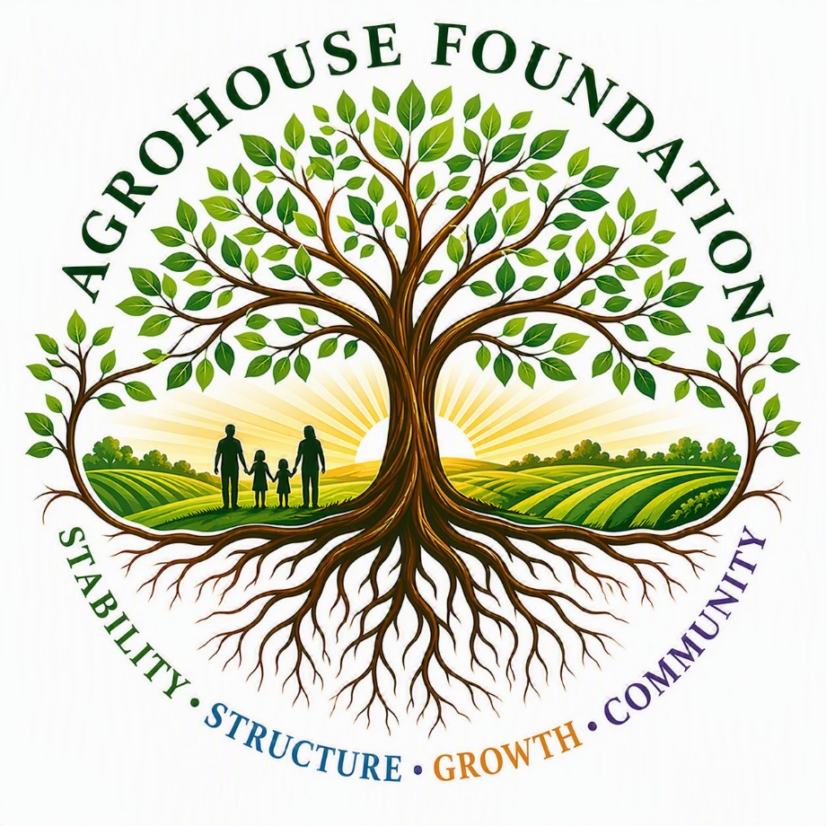
Program 1: Outreach Stabilization Program
Supporting and Strengthening Existing Community Outreach Systems

To Whom It May Concern,
The Outreach Stabilization Program represents the foundational first phase of AgroHouse Foundation’s™ integrated system.
This program is designed to support and strengthen multiple existing community-based food outreach efforts by improving consistency, reliability, and operational structure while long-term production systems are being developed.
Currently, outreach efforts within the community collectively serve approximately 250 individuals weekly across multiple distribution points. These outreach activities operate independently but serve a shared community need and goal of providing consistent food support.
AgroHouse Foundation™ does not seek to replace or take control of these efforts. Instead, this program operates in a supporting role—working alongside existing leadership to stabilize food supply, improve operational flow, and reduce strain on those currently serving.
The goal of this program is to create a stable and consistent foundation that allows outreach efforts to function effectively today, while preparing for future integration with sustainable food production, workforce development, and long-term community support systems.
This document outlines the structure, purpose, and implementation approach of the Outreach Stabilization Program and serves as the operational and strategic framework for its development.

Sincerely,
Maggie Baty
Founder
AgroHouse Foundation™

- PROGRAM PURPOSE
The Outreach Stabilization Program exists to support and strengthen a network of existing community food outreach efforts by improving consistency, reliability, and operational structure while long-term systems are being developed.
- CORE OBJECTIVE
Ensure that current outreach efforts operate consistently, reliably, and without strain while preparing for integration into sustainable, long-term systems.
- CURRENT OUTREACH STRUCTURE
The combined outreach efforts currently serve approximately 250 individuals weekly through multiple distribution points.
- Outreach Network Includes:
- Church-led outreach during the week under church leadership
- Additional independent outreach efforts within the community
These outreach activities operate independently but serve a shared community need and goal of providing consistent food support.
- PROGRAM POSITIONING
- SUPPORT ROLE
AgroHouse Foundation™ operates in a supporting role, working alongside existing outreach leadership to improve stability and sustainability.
- DOES NOT REPLACE OR CONTROL
- Does not take over outreach leadership
- Does not replace existing systems
- Does not alter the mission of existing outreach efforts

- ENHANCES AND STRENGTHENS
- Improves supply consistency
- Supports operational structure
- Reduces strain on outreach leadership

- PROGRAM STRUCTURE

- FOOD SUPPLY STABILIZATION
A. Methods:
- Food bank partnerships
- Grocery donation programs
- Community donations
- Limited bulk purchasing when necessary
Goal: Provide a reliable and predictable weekly food supply across outreach efforts.

- OUTREACH SUPPORT SYSTEM
- Functions:
- Improve intake, sorting, and preparation flow
- Assist with organization of distribution
- Support volunteer coordination without replacing leadership
- Outcome:
- Smoother outreach operations
- Reduced strain on leadership
- Improved efficiency

- DISTRIBUTION SUPPORT
Approach: Maintain existing outreach structure while improving efficiency without disruption
- Examples:
- Organized staging areas
- Structured distribution flow
- Improved packing systems
- FOOD BOX PROGRAM (INITIAL PHASE)
Purpose: Provide extended support to select households
- Initial Implementation:
- Begin with 10–20 families
- Expand gradually as supply stabilizes
- Outcome:
- Increased consistency for families
- Improved resource management
- Foundation for future growth
- OPERATIONAL FLOW
WEEKLY FLOW: Food Sourcing → Intake → Sorting → Preparation → Distribution → Cleanup
- ROLES & RESPONSIBILITIES
- Church Leadership
- Oversees outreach operations
- Maintains community connection
- Provides direct leadership
- AgroHouse Foundation™
- Supports supply stabilization
- Assists in improving structure
- Helps build long-term sustainability
- Volunteers
- Assist with sorting, preparation, and distribution
- Support outreach efforts as needed

- FUNDING MODEL
DEBT-FREE OPERATION: The program operates without reliance on loans or debt, scaling only within available resources to ensure long-term sustainability.
- FUNDING SOURCES
- Community donations (monetary and food)
- Food bank partnerships
- Small local and corporate grants
- Faith-based and community support initiatives
- TARGET FUNDING OPPORTUNITIES
- Walmart Community Grants
- Publix Charities
- Local community foundations
- Regional hunger relief programs
- Faith-based outreach support programs
These funding sources are used to stabilize supply and support operational consistency, not to create dependency or overexpansion.
- FUNDING & IMPLEMENTATION PHASES
PROGRAM FUNDING PRINCIPLE: The Outreach Stabilization Program grows within its means, ensuring that each phase builds stability before expansion.
Growth occurs based on capacity—not pressure—ensuring long-term sustainability.
PHASE 1: INITIAL STABILIZATION
Objective: Establish consistency and reduce instability in current outreach efforts
- Focus:
- Secure food supply sources
- Identify supply gaps
- Introduce basic organization
- Funding:
- Small grants
- Food bank partnerships
- Community donations
- Outcome:
- Reliable weekly outreach
- Reduced uncertainty
PHASE 2: STRUCTURE & CONSISTENCY
Objective: Create repeatable, structured operations
- Focus:
- Improve workflow and organization
- Strengthen volunteer coordination
- Launch small food box program
- Funding:
- Continued grant support
- Growing community contributions
- Outcome:
- Consistent, efficient operation
- Increased capacity without strain
PHASE 3: SUPPLY STRENGTHENING
Objective: Reduce reliance on inconsistent supply sources
- Focus:
- Strengthen supply partnerships
- Expand food distribution capacity
- Funding:
- Larger grants
- Established donor support
- Outcome:
- Stable food supply
- Increased reliability across outreach
PHASE 4: TRANSITION TO PRODUCTION SUPPORT
Objective: Begin integration of farm-based food production
- Focus:
- Introduce locally produced food
- Reduce dependency on external sources
- Funding Approach:
- Transition from stabilization funding to system development
- Outcome:
- Partial self-sustainability
- Stronger long-term system
PHASE TRANSITION PRINCIPLE: Each phase builds on the previous one. Expansion only occurs after stability is achieved.

- SCALING STRATEGY
- The program grows based on:
- Supply availability
- Operational stability
- Volunteer capacity
- Confirmed funding support
- Not based on:
- Demand pressure alone
- Expansion without structure
- Financial risk
- INTEGRATION WITH FUTURE PROGRAMS
- Agricultural Production Program
- Provides long-term food supply
- Reduces reliance on external sources
- Workforce Development Program
- Optional participation
- Builds skills and responsibility
- Vocational AgroHouse Program
- Expands workforce and production capacity
- Supports long-term sustainability
- SUCCESS INDICATORS
- Short-Term Success
- Outreach consistently serves ~250 individuals weekly
- Reduced supply shortages
- Improved operational flow

- Mid-Term Success
- Increased consistency and reach
- Food box program established
- Long-Term Success
- Farm provides part of food supply
- Reduced External Dependency
- Fully stabilized outreach system
- CORE PRINCIPLES
- Support, Not Replace
- Stabilize Before Expanding
- Structure Without Disruption
- Voluntary Participation
- Build Toward Sustainability
PROGRAM TRUTH: AgroHouse Foundation™ strengthens a network of existing outreach efforts by providing stability, structure, and support while building toward a fully integrated, sustainable system.

